**Spring Boot**

Spring Boot is a Spring module that provides the RAD (Rapid Application Development) feature to the Spring framework. Spring Boot is a project that is built on the top of the Spring Framework. It provides an easier and faster way to set up, configure, and run both simple and web-based applications.

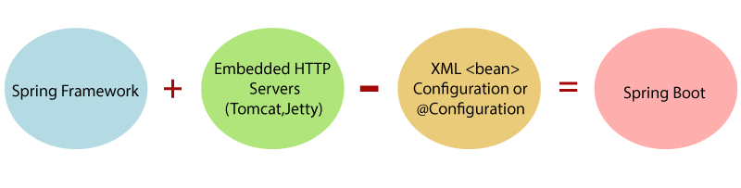

Advantages

Spring Boot offers the following advantages to its developers −

* Easy to understand and develop spring applications
* Increases productivity
* Reduces the development time

Goals

Spring Boot is designed with the following goals −

* To avoid complex XML configuration in Spring
* To develop a production ready Spring applications in an easier way
* To reduce the development time and run the application independently
* Offer an easier way of getting started with the application

Why Spring Boot?

You can choose Spring Boot because of the features and benefits it offers as given here −

* It provides a flexible way to configure Java Beans, XML configurations, and Database Transactions.
* It provides a powerful batch processing and manages REST endpoints.
* In Spring Boot, everything is auto configured; no manual configurations are needed.
* It offers annotation-based spring application
* Eases dependency management
* It includes Embedded Servlet Container

How does it work?

1. The application is started from the Java main class
2. Spring boot initializes Spring context that comprises the Spring app and honours autoconfig initializers, configuration and annotations which direct how to initialize and startup the spring context
3. Embedded server container is started and autoconfigured
   1. This removes the need for web.xml
   2. Spring has chosen “Tomcat” as the default container

Main class has following annotation.

@SpringBootApplication

A convenience annotation that wraps commonly used annotations.

Used in place of the following 3 different annotations

1. @Configuration : Instructs that a Spring configuration class is being used instead of XML to define the components

2. @EnableAutoconfiguraton : is a Spring boot specific annotation

Instructs that the application should auto configure the other frameworks included as dependency with Spring.

3. @ComponentScan : Scans project for Spring components annotated with @Service, @Repository, @Component